- Purpose

The purpose of this document is to describe the specifications and design that will be implemented for the Analysis Functions in the ClearView system.

- General Requirements

Where appropriate, logic should be contained in try/catch blocks and any exceptions should be logged using the standard logging mechanisms.

- Specifications

Requirement #1: Image analysis must take place immediately upon request by the user after all of the images are captured.

Specification: Once all of the images have been captured and before anything is committed to the database the 'Submit for Analysis' button will become enabled. When the user presses this button, the system will prevent any other buttons from being pressed. The system will then begin the analysis process.
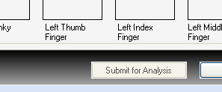
Once the images have been collected, the user only has two choices, either cancel the process as a whole, or run the analysis.

Requirement #2: Analysis requires a set of 10 filtered and 10 unfiltered images.

Specification: Before the analysis process can begin a collection of twenty images must be captured. Ten of the images are to be collected without a filter and ten with a filter. The user cannot continue the process until all twenty images have been captured.

Requirement #3: A valid calibration set must be current and available before analysis can begin.

Specification: In order to access the capture process, a check is done by the system before displaying the capture dialog to verify that a calibration is stored and available. The rules as to what a valid calibration consists of are defined in the Camera Functions- Specifications. If no calibration is available, the user is not allowed to go to the capture screen and a message is displayed letting them know that a calibration must be run.

Requirement #4: The system must calculate a noise value which will be referred to as the background noise level. This level should be the pixel intensity below which will be considered 0 or no intensity at all.

Specification: The background noise level is calculated by determining at what intensity level only .02% of the pixels in the middle of the image are lit. The center of the image is used because in theory this should be an area completely void of light and therefore representative of what the background of the image should look like.
The routine will iterate through the following loop until the result of the final calculation is < .02% of the total area in question.
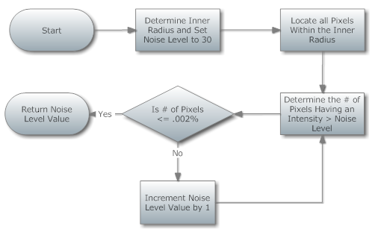
When the comparison returns true, we have arrived at the Background noise value, in most cases this value is between 30 and 45.

Requirement #5: Energized finger images are to be divided for analysis into sectors; these sectors are to be unique for each finger and will be known as finger sectors. All calculations will be done based on the area within the specified sector.

Specification: The size of each finger sector is defined in the ClearView Finger Sector Map which specified the beginning sector angle and the ending sector angle labeled by the finger name and the ultimate organ system label used to store the results.

Requirement #6: The number of pixels within a sector that are above the noise level should be measured, this coefficient will be known as the sector area.

Specification: The area is the number of pixels that have intensity greater than a specified noise level within a given sector. The pixels contained in the sector are determined by selecting all pixels inside the ellipse that are contained within a certain angle segment corresponding to this sector. The value returned for this calculation is between 0 and the number of pixels in the largest defined sector.

Requirement #7: The area respective to the size of the sector must be calculated, this coefficient will be known as the normalized area.

Specification: This is the area value determined above, that is then normalized for the size of the sector that it represents. The normalization process is given by the formula:
Area Value * ((360 / #of Sectors)/ Angle of the sector)

Requirement #8: The average intensity of all pixels in a sector must be determined; this coefficient will be called average intensity.

Specification: The Average Intensity per sector is computed by dividing the sum of intensities of all pixels in the sector area by the number of pixels in the sector area.

Requirement #9: The measurement of disorganization in a sector should be measured; this coefficient will be known as the entropy.

Specification: The Entropy of each sector is computed by first computing the standard Shannon Entropy along each profile. The profiles are created through the following process:
The image is traversed radially in a clockwise manner with the center point of the ellipse serving as midpoint. This is done in steps of 1/4 of an angular degree. For each of the resulting 360x4 = 1440 angles, an image profile is computed by choosing the pixels from the active area that intersect with a ray at one of the 1440 angles and centered at the ellipse midpoint.
The final value is determined by calculating the entropy of each profile within a sector and then averaging the result across all profiles within the sector.

Requirement #10: Measure the level of continuity along the radii of the sectors, this coefficient will be known as form. The form coefficient will encompass approximately 2/3 of the depth of the sector.

Specification: After having determined the active area of the finger image as described above, the image is traversed radially in a clockwise manner with the center point of the ellipse serving as midpoint. This is done in steps of 1/4 of an angular degree. For each of the resulting 360x4 = 1440 angles, an image profile is computed by choosing the pixels from the active area that intersect with a ray at one of the 1440 angles and centered at the ellipse midpoint. Furthermore, the active image area is divided into three concentric rings. The form value for each sector consists of three coefficients, one for each of the three rings. Each such coefficient is a weighted sum of three different coefficients C1,C2,C3.
The coefficient C1, the derivative coefficient, measures the amount of change in pixel intensity along each profile within a given ring. Amount of change is quantified by computing the derivative of the aforementioned profile.
The coefficient C2 measures whether there is a gap in the inner finger image contour and assigns a value corresponding to the size of such a gap.
The coefficient C3 measures whether there is an abrupt break (sudden drop in pixel intensity) along the profiles. For robustness against noise, several profiles are analyzed simultaneously for the presence of a break.

Requirement #11: The form coefficient will encompass approximately 2/3 of the depth of the sector, a separate coefficient called Form2 will look at the outer 1/3 of the sector.

Specification: The Form2 value is computed by using a weighted sum of the derivative coefficients for the first and second ring described in the Form calculation.

Requirement #12: Breaks or lines in a sector will be known as Break Coefficient.

Specification: The break coefficient for each sector is computed by measuring whether there is an abrupt break (sudden drop in pixel intensity) along the profiles.
In contrast to the break coefficient computed in 1., a different metric is used that depends on a separately provided noise level.
For robustness against noise, several profiles are analyzed simultaneously for the presence of a break.

Requirement #13: A measurement of the fractal dimension in a sector must be calculated, this coefficient will be known as fractal.

Specification: The Fractal Dimension of the active area in a sector is computed by computing the fractal dimension (in its mathematical sense) using the standard box-counting method for a two-dimensional area.

Requirement #14: A measurement of the difference between a calibration image and the captured energized image per sector must be reported, this coefficient will be known as NS.

Specification: The NS value is computed via the formula:

Average Intensity(Image sector) / Aver. Int.(Calibration sector) -------------------------------------------------------------------------------------------------------- - 0.5
L_Image / L_Calibration

Where:
L_Image = Log (Number of active pixels/Number of total pixels + epsilon) per each sector of the finger image.
L_Calibration = Log (Number of active pixels/Number of total pixels + epsilon) per each sector of the calibration image;
Here, the value epsilon = 10^(-4) is added for stability reasons to avoid that the values of L_image and L_Calibration become too small (which would happen in the rare case of numerator and denominator being almost identical).The value 0.5 in the above formula is subtracted for normalization purposes.
When these coefficients have been calculated for each sector on each finger, the results are persisted into systems database for use in the next section.

Requirement #15: The general data flow will be as follows:
Collect images → Perform coefficients calculations → Store raw data → Run coefficients through analysis algorithm → Result in Response Scale Measurement → store analyzed data → produce a report.

Specification: The system has been programmed to the following flow, each of these areas are defined in subsequent documents:
- Select a patient.
- Collect the images (Capture Specifications).
- Generate coefficients from the images (Analysis Specifications).
- Save the images and raw data to the database.
- Perform the analysis of the coefficients (Analysis Specifications).
- Produce the report output.

Requirement #16: The raw coefficients should be persisted in their original state in a table in the ClearView database.

Specification: The data is stored in a table called AnalysisResults. The table is uniquely keyed by an id, and is referenced back to the treatment by a PatientTreatmentId value.
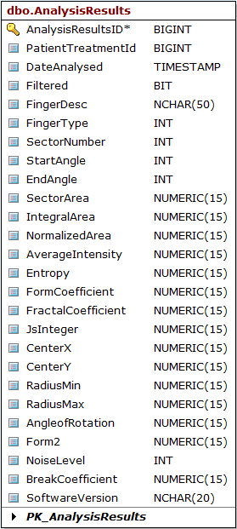
Requirement #17: Z Scores will be calculated for each instance of all coefficients.

Specification: The algorithm will perform the following processing on each of the listed coefficient data sets [Area, Average Intensity, Entropy, Form1, Form2, Fractal, NS Integer]
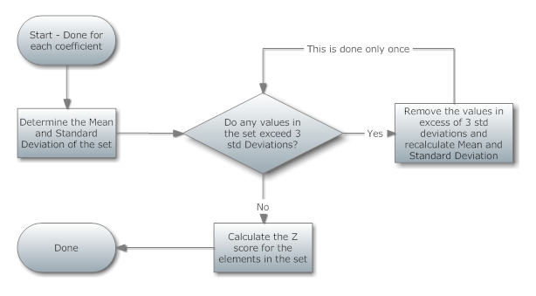
Once the Z scores are created, they are temporarily persisted in memory as the analysis process moves to the next phase.

Requirement #18: A base score will be calculated for each finger sector, this score is a product of the weighting factor (which is unique to each coefficient), the calculated coefficient and the coefficient z-score.

Specification: Once the Z scores have been established, for all coefficients and all of their instances, they can then be further developed into a base score. The base score is defined as shown below for each coefficient and instance of the coefficient:
Base Score = Z Score * Measurement * Weighting Factor
The weighting factor is determined by the type of coefficient being calculated, the table below shows the weightings for each coefficient.
Coefficient | Weighting Value
Entropy | 1500
Form1 | 300
Form2 | 300
Area | 0.5
Average Intensity | 25
NS Integer | 3500
Fractal | 225

Requirement #19: Specific combinations of high scoring coefficients will be worth more than others. Rules will be put in place to enforce this.

Specification: Once a base score has been established, a significance factor is then calculated. This is an additional value that would be added to the base score. The significance score is used to flag specific combinations of coefficient values that may represent a higher risk of issue.
Three rule sets are applied to each of the sectors that were analyzed. The flow of the process is shown below:

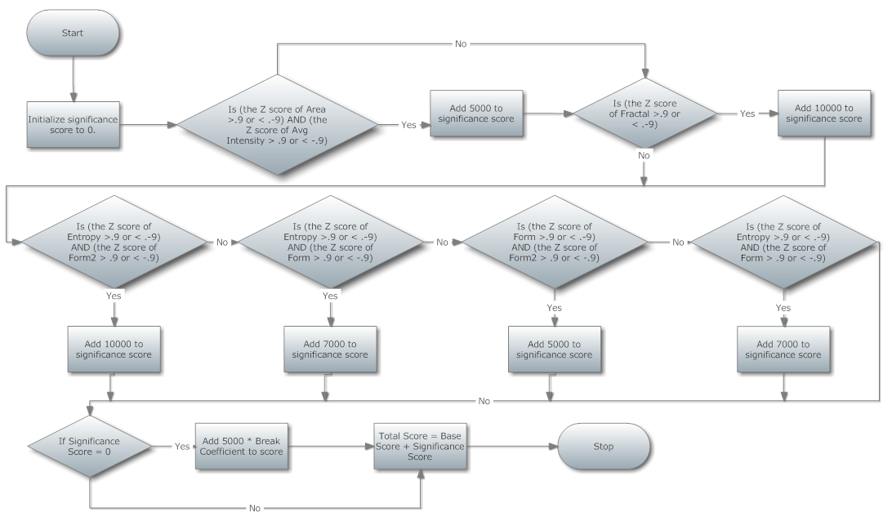
Requirement #20: A scale will then be applied to the score that was created, the scale will reduce the results to a number between 1 and 25.

Specification: The final step to produce the score for the given sector is to divide the total score by 100 and determine where in the table below the score resides. The value in the score column is what is returned to the user.
Raw Value Between | Score
>= 600 | 25
599 and 560 | 24
559 and 520 | 23
519 and 480 | 22
479 and 440 | 21
439 and 400 | 20
399 and 360 | 19
359 and 320 | 18
319 and 280 | 17
279 and 240 | 16
239 and 200 | 15
199 and 183 | 14
182 and 166 | 13
165 and 149 | 12
148 and 132 | 11
131 and 115 | 10
114 and 100 | 9
99 and 94 | 8
93 and 90 | 7
89 and 86 | 6
85 and 75 | 5
74 and 64 | 4
63 and 53 | 3
52 and 42 | 2
41 and 30 | 1
< 29 | 0

Requirement #21: Calibration images must be saved with the raw data.

Specification: A reference to the table containing the calibration images that were used in the calculation for a given subject will be stored with the patient data. This reference will allow the calibration images to be viewed or extracted at a later time.

Requirement #22: The final report data must be saved to the ClearView database.

Specification: The final score data will be saved in a table called Severity in the ClearView database. The definition of the table is shown below:

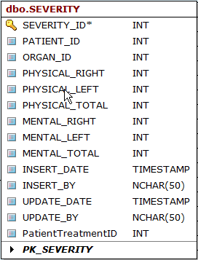
Requirement #23: The user will have the ability to print a report of the Response Scale measurements.

Specification: The final reported Response Scale value is organized into a table listed by organ/structure with high level organ systems (i.e., Sensory & Skeletal Systems, Nervous & Immune Systems, Respiratory System, Cardiovascular System, Stomach & Small Intestine, Endocrine & Metabolism, Gastro intestinal & Large Intestine, and Renal & Reproductive) that is ready to be printed. This printable report is located in the Print Report tab displayed when the analysis is complete. The measurements are separated by Physical (images taken with a filter in place) and Autonomic (images taken without a filter in place) into columns that report the right and left hand results. Additionally, measurements are reported with Normal values (measurements = 0 through 14) being displayed in a separate column than the Out of Normal values (measurements between 15 and 25). Out of normal values between 15 and 19 are displayed in red ink and out of normal values between 20 and 25 are displayed in red ink with the display box highlighted in yellow. The Organ System label is also changes to red ink for any organ system with an out of normal measurement reported. Fingers that do not report a result (i.e., organ systems for finger sectors that are only on one hand), a zero will be reported for this value. If an image results in a calculation that is unable to be performed (i.e., dividing by zero, etc.), the Response Scale value reported is -1 in red ink displayed in the Normal column.

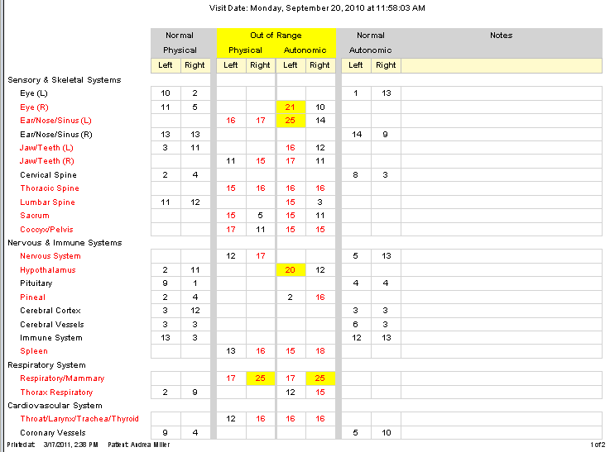

Requirement #24: The user will have the ability to view and sort the Response Scale measurements.

Specification: The final reported Response Scale value is organized into a table listed by organ/structure and displayed on a Worksheet tab when the analysis is complete. The measurements are separated by Physical (images taken with a filter in place) and Autonomic (images taken without a filter in place) into columns that report the right and left hand results. The organ/structure labels may be displayed in black ink and/or with unique ink combinations to identify the overall organ system (i.e., Sensory & Skeletal Systems, Nervous & Immune Systems, Respiratory System, Cardiovascular System, Stomach & Small Intestine, Endocrine & Metabolism, Gastro intestinal & Large Intestine, and Renal & Reproductive). Each column heading can be sorted by clicking on the column heading. The measurements will first sort for highest to lowest upon the first click of the column heading and then lowest to highest on the second click of the column heading.

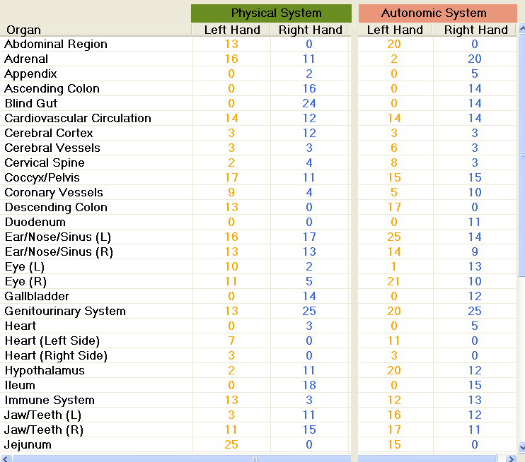

Requirement #25: The user will have the ability to view a graphical representation of the NS coefficient.

Specification: The NS coefficient calculations are displayed on a graph displayed in the NS Analysis tab when the analysis is complete. A graphical representation (representing a male physiology for male patients and female physiology for female patients) of the human body is displayed in the middle with the organ/structure label placed in an approximate correlated location to the organ/structure location on the body. A line graph is used to approximate the z-score values for each organ/structure. The autonomic result is displayed in a different color than the physical result. Different rings of grey increasing in density from the inside out display an approximation of the z-score value starting on the inner ring at -2 and moving outward incrementing by a whole number (i.e., -1, 0, 1, and 2).

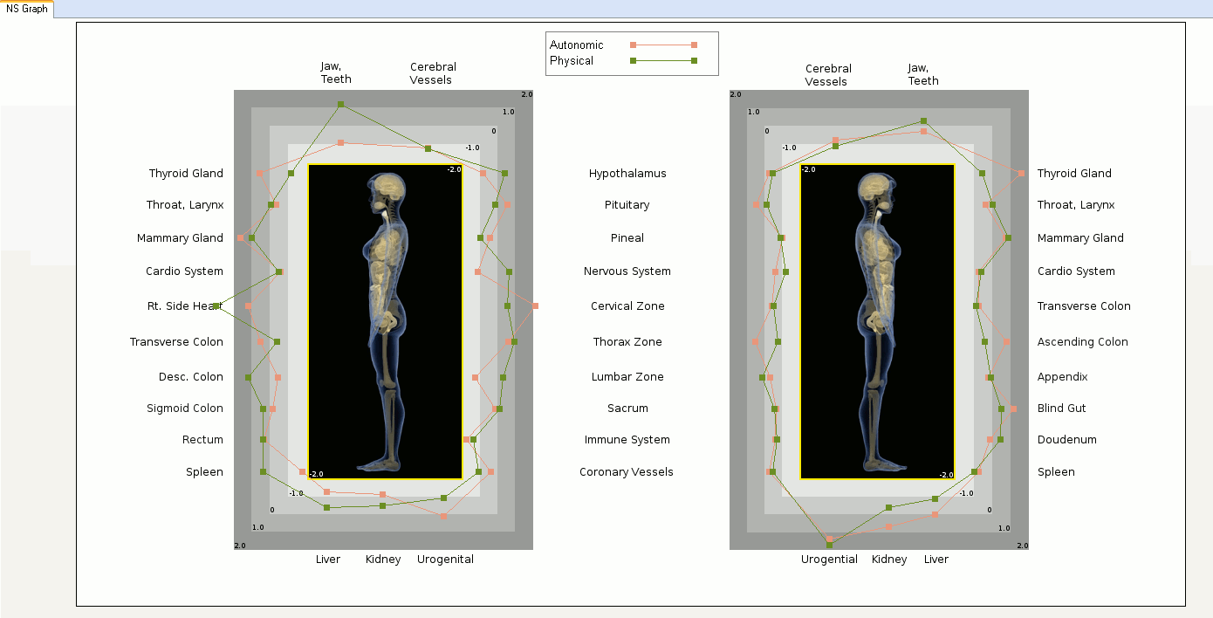

Requirement #26: The user will have the ability to view the energized image sectors in relation to a visual representation of the body.

Specification: The energized image sectors are stretched and placed on image that represents the approximate location of the organ system and the image sector is specifically located to the organ/structure being reported. These images are referred to as Biofield images. These images are modified for each different body organ system. As the mouse travels over the displayed energized image sector, the Response Scale measurement designated by physical and autonomic and left and right had are displayed. The EPIC administrators also have access to a view of the entire energized finger image displayed to the left of the biofield images. These complete energized images will have two radii representing the edges of the finger sector being highlighted by the mouse over. Additionally, the entire energized image can be displayed in black and white or with color intensity that represents the differences in intensity present in the image.

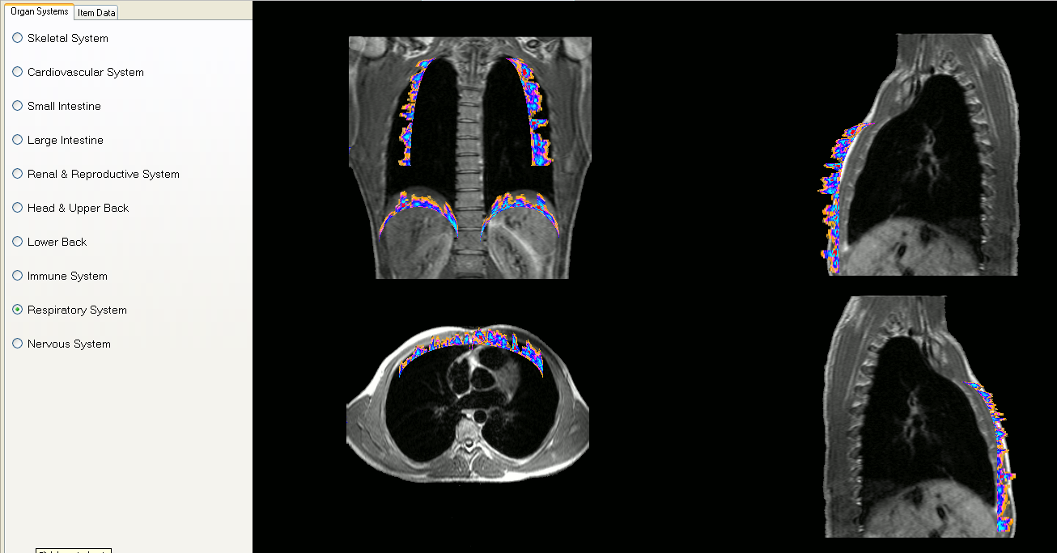

- Reference Documents

SS-204, Camera Functions- Specifications
SS-203-01, ClearView Finger Sector Map

Document Revision History
Version Number: | Description of Change: | Date: | Updated by:
000 | Introduction | 5/24/11 | A. Mason

